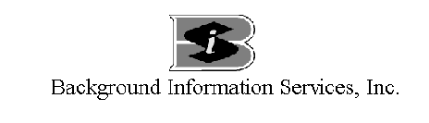
Notification Form

The purpose of this form is to notify you that a consumer report will be run on you in the course of consideration for employment with:

Company Name: Acct#:

Please Print or Type

Last Name_______________________________First_____________________________Middle__________________

Social Security #_______________________________Date of Birth_____________________Age_________________

Driver’s License Number___________________________________State of Issue______________________________

Present Address___________________________________________________________________________________

In connection with this request, I authorize all corporations, former employers, credit agencies, educational institutions, law enforcement agencies, city, state, county and federal agencies, military services and persons to release information they may have about me to the person or company with which this form has been filed, or their agent, Background Information Services, Inc. This releases the aforesaid parties from any liability and responsibility for collecting the above information.

I authorize a consumer credit report to be run. I also authorize the release of my motor vehicle driving records maintained by law enforcement agencies, city, state, county and federal courts, or any other state or local agency, to the person or company with which this form has been filed or their agent, Background Information Services, Inc..

This releases the aforesaid parties from any liability and responsibility for collecting the above information. I understand that these files may contain negative information about my background, mode of living, character, and personal reputation. This authorization, in original or copy form, shall be valid for this and any future reports or updates that may be requested.

__________________________________________________________________________________________/_____/_____

Applicant’s Signature Date

